|  |  |
| --- | --- |
| **NOMBRE:** | Díaz Padilla Danny Sebastián. |
| **FECHA:** | 08-01-2020 |
| **TÍTULO:** | “Face emotion recognition” |

Captura de la ejecución

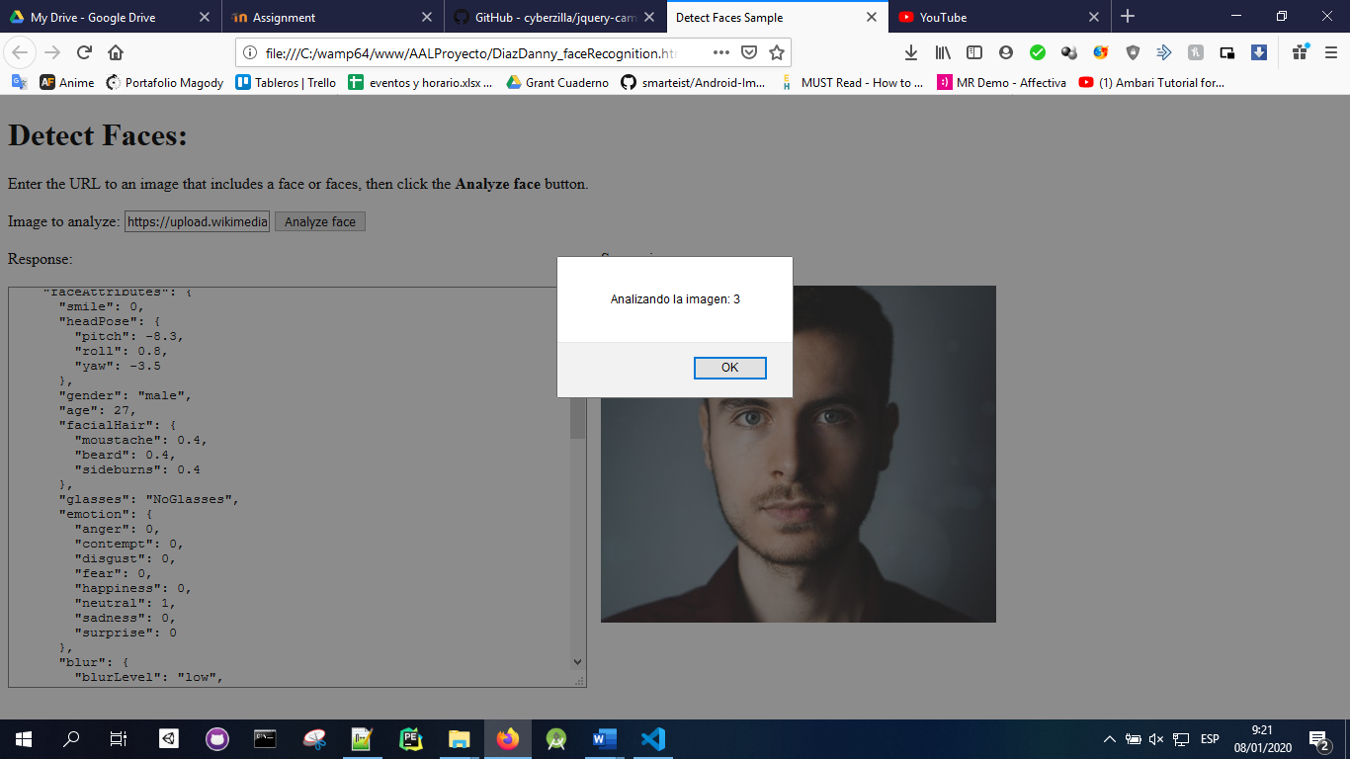

Código fuente:

<!DOCTYPE html>

<html>

    <head>

        <title>Detect Faces Sample</title>

        <script src="https://ajax.googleapis.com/ajax/libs/jquery/1.9.0/jquery.min.js"></script>

    </head>

    <body>

        <h1>Detect Faces:</h1>

Enter the URL to an image that includes a face or faces, then click

the <strong>Analyze face</strong> button.<br><br>

Image to analyze: <input type="text" name="inputImage" id="inputImage"

    value="https://upload.wikimedia.org/wikipedia/commons/c/c3/RH_Louise_Lillian_Gish.jpg" />

<button onclick="processImage()">Analyze face</button><br><br>

<div id="wrapper" style="width:1020px; display:table;">

    <div id="jsonOutput" style="width:600px; display:table-cell;">

        Response:<br><br>

        <textarea id="responseTextArea" class="UIInput"

            style="width:580px; height:400px;"></textarea>

    </div>

    <div id="imageDiv" style="width:420px; display:table-cell;">

        Source image:<br><br>

        <img id="sourceImage" width="400" />

    </div>

</div>

<script type="text/javascript">

    var tiempo = 30000; //ms

    var imagenes = [

        "https://images.pexels.com/photos/415829/pexels-photo-415829.jpeg?auto=compress&cs=tinysrgb&dpr=1&w=500",

        "https://images.pexels.com/photos/614810/pexels-photo-614810.jpeg?auto=compress&cs=tinysrgb&dpr=1&w=500",

        "https://inst.eecs.berkeley.edu/~cs194-26/fa17/upload/files/proj4/cs194-26-adq/asianguy.jpg",

        "https://steemitimages.com/p/EEEoA8oLaAxsTkPYAARp78o5cJA1o6Chv9x98TzCFT6v5GzSgNSrek2mrGEULjaHfyNgCUG12gcqiHgDDeVfSvrek7wMk5SPxC9sLjwSJcA7JHBFJFWAedmwvV5dgqVTLnF6u4DCsbMUhqKXQnmVg?format=match&mode=fit&width=640",

        "https://facegen.com/images/modeller_photofit_1.jpg"];

    var indice_imagen_actual = 0;

    processImage();

    var intervalo = setInterval(processImage, tiempo);

    function processImage() {

        alert("Analizando la imagen: "+(indice_imagen_actual+1));

        /* Ekman emotions

        Key 1: d9b62f5bd12847d6bb959d870abafb0a

        Key 2: f2789e1a750d4fc7be518f50ddf7524b

        */

        var subscriptionKey = "d9b62f5bd12847d6bb959d870abafb0a";

        var uriBase =

            "https://westcentralus.api.cognitive.microsoft.com/face/v1.0/detect";

        // Request parameters.

        var params = {

            "returnFaceId": "true",

            "returnFaceLandmarks": "false",

            "returnFaceAttributes":

                "age,gender,headPose,smile,facialHair,glasses,emotion," +

                "hair,makeup,occlusion,accessories,blur,exposure,noise"

        };

        // Display the image.

        var sourceImageUrl = imagenes[indice_imagen_actual] //document.getElementById("inputImage").value;

        document.querySelector("#sourceImage").src = sourceImageUrl;

        // Perform the REST API call.

        $.ajax({

            url: uriBase + "?" + $.param(params),

            // Request headers.

            beforeSend: function(xhrObj){

                xhrObj.setRequestHeader("Content-Type","application/json");

                xhrObj.setRequestHeader("Ocp-Apim-Subscription-Key", subscriptionKey);

            },

            type: "POST",

            // Request body.

            data: '{"url": ' + '"' +sourceImageUrl +'"}', // data: '{"url": ' + '"' + sourceImageUrl + '"}',

        })

        .done(function(data) {

            // Show formatted JSON on webpage.

            $("#responseTextArea").val(JSON.stringify(data, null, 2));

        })

        .fail(function(jqXHR, textStatus, errorThrown) {

            // Display error message.

            var errorString = (errorThrown === "") ?

                "Error. " : errorThrown + " (" + jqXHR.status + "): ";

            errorString += (jqXHR.responseText === "") ?

                "" : (jQuery.parseJSON(jqXHR.responseText).message) ?

                    jQuery.parseJSON(jqXHR.responseText).message :

                        jQuery.parseJSON(jqXHR.responseText).error.message;

            alert(errorString);

        });

        indice_imagen_actual += 1;

        if(indice_imagen_actual == imagenes.length){

            indice_imagen_actual = 0;

            clearInterval(intervalo);

        }

    };

</script>

    </body>

</html>

Captura de la misma cara

